Term ends | Pres | 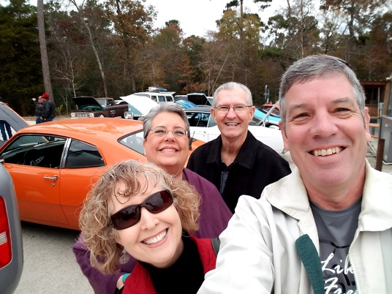  Directors
2019 | X | Mitzi Kline - President
2020 | X | Leslie Herndon - Vice President
2021 |  | Shannon Gardner - Treasurer
2020 | X | Alaina Arnold - Past President
Perm | X | Cody Abshier - Superintendent  Ken and D-Ann Berry and Sherri and Bruce Wright at Foundation Day at the Crawfish Place in Anahuac on Dec 16th. It was fun.
Perm | X | Margaret Gardzina - Lifetime
2020 | X | Brandon Davis
2021 |  | Logan Pickett
2021 | X | 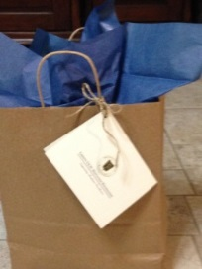  David Rodriguez  Alma distributed old Freedom Ride T-shirts in gift bags to some of our sponsors.
2021 |  | Rosie Lopez
2021 | X | Darell Pruett
2021 | X | D-Ann Berry
2019 | X | Justin Johnston
2020 | X | Fallon Kay
2020 | X | Laura Hernandez
2020 | X | Stephanie Deberry
 | X | Bruce Wright - Foundation Coord.
Informational items and calendar
- Continue praying for Kristi and Cody Abshier.
We received a nice note for the flowers given by
the Foundation Directors.
- Shannon brought a potential grant group idea
from the Meadows Foundation in Dallas to help with cost of new students because of Hurricane Harvey. Shannon reports that we do not qualify under their guidelines … but good work!
- In December, large donations were received from Margaret Gardzina, Colette Leonard and Sandra Sterling.
- Miles Foundation meeting update – Bruce spent time describing the visit with Grant Coates from the Miles Foundation on Oct 11 in Ft Worth. The Miles Foundation is looking to honor Ellison Miles on his 100th birthday on May 6th by donating a large sum of money ~100K. We need to figure out what would fit their needs.

Regular Meeting Items:
- Officers and personnel – A motion was made by Brandon Davis, seconded by Alaina Arnold to elect Mitzi Kline as President and Leslie Herndon as VP. Motion was voted on and passed before anyone could change their mind! Alaina will be Past President. Brandon gets a break.
  - Thanks and well wishes to Alma Yanez, Sandra Garcia and Ashley Balch who have elected not to extend their terms.
  - D-Ann, David, Rosie and Darell have signed on for another term.
- Welcome – Mitzi welcomed everyone and recognized our guest Jessika Kirkland. Jessika is considering working with the foundation.
- Presentation of 2018 Annual Report
  - President’s letter and p1 - Mitzi referred to the Annual report document and covered her letter and the goals of the Foundation.
  - Coordinator’s summary – Bruce covered the remaining items in the report with detail and frequent discussion from directors. The summary lays out our successes from last year and points to our focuses for 2018.
  - Treasurer's report and financial updates – Bruce covered the financial items in the Annual report in Shannon’s absence. A error was noted by Leslie under Total bank accounts 12/31/11. We will amend that number.
  - Calendar for 2018 – Bruce urged all to place this calendar on their devices for reference to all next year’s meetings.
- Approval of the Annual Report 2017 – Margaret made a motion, seconded by Leslie to approve the Annual Report with changes. Motion passed.
- Superintendent‘s report – Cody reported that varsity boys basketball team under coaching by Jason Wickliff has been doing very well with a win against H-J and hoping for a playoff birth, the first in a while. He also gave attention to Mark Patterson, LMS Choir teacher who accomplished 23 1st Division ratings for his students at Regional Choir competition. D-Ann added a pat on the back for the LHSD Decathlon team and Band for their recent showings. Rob and Jessie Kirkland put on a fine and successful baseball banquet netting $14,000 for the program.
- Liberty Freedom Ride 2018 personnel and planning – Mitzi and Bruce went over assignments and needs for the April 7, 2018 event.
Station | Worker |  | Station | Worker
Event coordinator | Bruce Wright |  | Registration | Laura Hernandez
Route director | Cody Abshier |  |  | Rosie Lopez
Route signage | Stephanie Deberry |  |  | Angie Vinson
Communications | Leslie Herndon |  |  | Sherri Wright
Hamm comm. | Andy West |  |  | Alaina Arnold
Mechanical Support | Don Armentrout |  |  | Shannon Gardner
 | Tom Simon |  |  | Sonia Mintz
Medical Director | Steve Ellerbe |  | Food -finish line | Brandon Davis
Liberty PD | Chip Fairchild |  |  | D-Ann Berry
Constable | Justin Johnston |  |  | Liz Kemp
SAG | Logan Pickett |  |  | Prancers
 | David Rodriguez |  | Welcome | Mayor Carl Pickett
Motorcycle escorts | Rick Vinson |  | Announcer/Starter | Bruce Wright
 | Jim Langford |  | Sound /music
 | Mike Pierson |  | Photographer | Joe Roberts
 | Bruce Mintz |  | Sponsors/ banners | Darell Pruett
Social Ride Coord. | Mitzi Kline |  | Hot Spot | Lindsay Matlock
Rest stops | Fallon Kay |  | Pace car #1 driver | Margaret Gardzina
Supply Logistics |  |  | Pace car #2 driver

- Other items:
- Brandon Davis asked about sponsorships for LFR and Bruce handed out the most current list on all donors from 2008-present. This document should help plan for contacting our potential donors/sponsors for 2018. Brandon said he’d coordinate the sponsorship drive.
- Due to traffic and work, Laura Hernandez was a little late to the meeting but she fought to be here. We discussed some other items after the meeting:
  - Become more of a year-round effort using June/July gap in our schedule for planning alumni focused events:
    - Spindletap – Humble
    - Sonoma Wine Bar – Heights
  - Creating a “Giving Tuesday” event in November
  - Increase our Fb presence by featuring a “Grant highlight” every other Friday or so.
  - Doing a better job of managing our social media
- Adjourn

