Term ends | Pres | 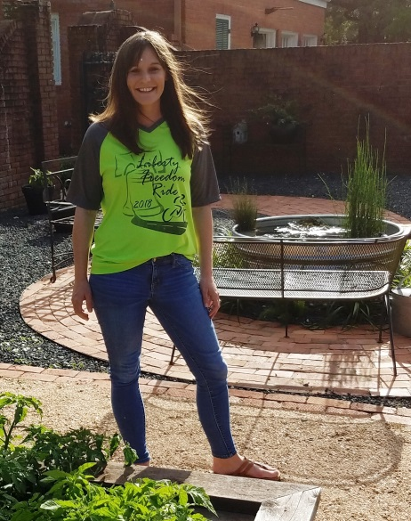  Directors
2019 | x | Mitzi Kline - President
2020 | x | Leslie Herndon - Vice President
2021 | x | Shannon Gardner - Treasurer
2020 | x | Alaina Arnold - Past President
Perm | x | Cody Abshier - Superintendent
Perm | x | Margaret Gardzina - Lifetime
2020 |  | Brandon Davis
2021 | x | Logan Pickett
2021 |  | David Rodriguez  Alaina, trying to help us sell some shirts! Way to go!
2021 |  | Rosie Lopez
2021 |  | Darell Pruett
2021 | x | D-Ann Berry
2019 | x | Justin Johnston
2020 |  | Fallon Kay
2020 | x | Laura Hernandez
2021 |  | Jessie Kirkland
 | x | Bruce Wright - Foundation Coord.

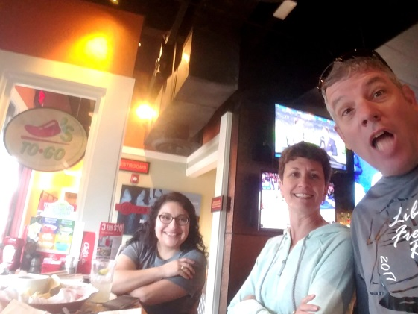
Chili’s Packet distribution event – Apr. 6

Calendar items:
Apr. 21 - Rescheduled Chili Rotary Cook-off
Apr. 24 - Grant Meeting (10AM – Noon)
May 2 - E. Miles event in Ft. Worth
May 14 - Next regular meeting – 5:30PM FLNB Corner
May 17 - Top 10 % recognition
May 25 - Graduation
Regular Meeting Items:
- Welcome – Mitzi welcomed all of the grant recipients, principals, guests and media reps. Phoptos were taken.
- Recognition of the 2018 Grant recipients - $16,187 – Press release and photo ops
Angela Brooks - Futuristic Architecture - $1477
Elisha Lemelle - Creating Tomorrow’s STEM Leaders - $7010
Oriana Cedeño - When I grow up… - $779
Carlene Patton - Awesome Hour - $3663
Andrea Hagan - Pedal to Success - $2694
Whitney Cain Shaw - Egg Incubation - $555
- Foundation photo
- Treasurer's report and financial updates (attached) – Shannon – Money has been transferred to grant acct. Motion to accept report Leslie, 2nd by Justin, motion passed.
  - Coordinator monthly work – 120 hrs
  - Schedule Executive Board meeting – May 14 5:30 at the Foundation office.
- Superintendent‘s report – Cody LMS and SJE are Capturing Kids Hearts National Showcase Campuses! Congratulations to them. Last rest stop signage was an issue but we know now.
- Liberty Freedom Ride 2018 recap –Laura H did a review of the good and bad of the event (included below). Everyone worked very well all the way until all was put away. Thanks to everyone.
2018 Liberty Freedom Ride Review
Items that worked well for 2018 ride that we need to continue doing in 2019
  - Registration :1 person checking in riders; 1 person handing out bibs; 1 person handing out ride map w/ contact info; 1 person handing out t-shirts; 1 person handing out bags; 1 person helping pin bibs on rider’s backs.
  - Sponsorship signage and route signage was well received, weathered well, and was a big cost savings.
  - Personal invitations worked well.
  - Great thanks for everyone staying and helping in all areas of clean up too
  - Food service worked well too
Items that need improvement for 2019 ride
  - Update contact info on ride map handed out to riders
  - Route signage (volunteer training) at Hardin Methodist Church
  - Work further ahead to secure beer sponsorship (Back Pew)
  - Meet with Ham radio guys and Motorcycle escorts at their meetings to coordinate more
  - Change food to something different (BBQ sandwich)
  - Eliminate rider T-Shirts for a cheaper substitute
  - Minute route changes to reduce need for rest stops and increase interest.
  - Think about using Ten de Mayo as packet pick-up destination
Items to keep in mind when scheduling or planning 2019 ride
  - Competing rides
    - http://www.wheelbrothers.com/texas-bike-rides/
    - Fort Bend Education Foundation ride & Bluebonnet Express
  - Conflicting local events
    - Little league opening day – (1st Saturday in April 6, 2019)
    - TVE fundraiser – April 6, 2019
Justin suggested a skeet event at Pecan Meadows as an additional fundraiser to help recover from the loss of income from Harvey. Justin will come up with a blueprint for an event and contact Jamie Burgess.
- Set date for LFR 4 – LFR 2019 Consider next yr. conflicting dates…Little League Apr 6, TVE Apr 6… Let’s get a group together to talk about bike ride.
- Update on the Miles Success Initiative
  - Miles birthday celebration – Wed. May 2, 2018 5-7PM (Ft Worth)
  - Tennis center, outdoor classroom etc…
- Adjourn
Liberty ISD Education Foundation EX-Comm Meeting May 14 Minutes
Present: Margaret Gardzina Alaina Arnold
Leslie Herndon Cody Abshier Shannon Gardner
Bruce Wright
Items:
- Discussion and action on the classification of the coordinator position - After extensive discussion, the group has concurred with Brandon’s opinion that the Foundation is following current rules that classify our coordinator position as “a contractor” rather than and employee. We believe this gives us much more flexibility too. Guiding information can be found at
  - (https://www.irs.gov/newsroom/understanding-employee-vs-contractor-designation )
- Senior Awards Night at LHS - Top 10 % recognition – Thursday, May 17 – 6PM
  - We need a presenter and a photographer. D-Ann (hand out medals) and Alaina (take pics) possibly.
- Discussion and possible action on finding a new accountant firm. Shannon believes that we might be better served with a different firm. Lindsay Baker at Bush, Sandhop and Baker was suggested. Brian Stephens at Davis CPA was also suggested. Cody also said Julie Hebert may be able to help getting the ISD’s firm to help too. The group authorized Shannon to make inquiries.
  - Current firm – Swaim and Brents
  - Fee – $1100 plus $ 40 for 1099
- Discussion and possible action on the continuation of the LFR and date for potential event. The group said that we should continue the LFR and evaluate after the 5 yr. event but not before.
- A summer focus group led by Laura H. covering Alumni focus and other possible events was authorized. Bruce will contact Laura and move from there. He said that her suggestions on our operations really haven’t received the airtime and focus that they should have. One of her suggestions was to use June as a great time to allocate our efforts on this and further planning.
- Advice and consent on a Miles Foundation letter of May 15, 2018 was sought. After the Ft. Worth trip, Leslie and Bruce were a bit disappointed. The letter states our work to this point and places the Miles group in the driver’s seat moving forward.
- The group stated that he Executive Comm. meeting was helpful and asked that we consider not waiting 3 yrs to the next one. Point taken!
Update Miles Foundation
Our donor, the Miles Foundation, that we were counting on to initiate our Miles Success Initiative (NCCER Summer Core Training project) is unable to support our project at this time. This is disappointing news. Long story short, they are unwilling to proceed with the MSI due to the high cost of a memorial pavilion project they wanted to accomplish too. I believe that the research and groundwork that we have done to support this project will lead us to something positive in the future but for now, our project is no longer.

