Term ends | Pres | 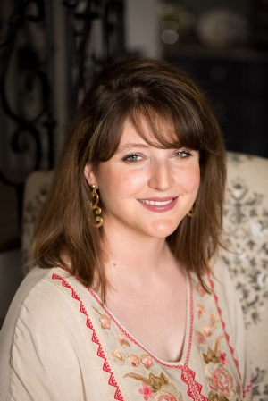  Directors
2019 | x | Mitzi Kline - President
2020 | x | Leslie Herndon - Vice President
2021 | x | Shannon Gardner - Treasurer
2020 |  | Alaina Arnold - Past President
Perm |  | Cody Abshier - Superintendent
Perm | x | Margaret Gardzina - Lifetime
2020 | x | Brandon Davis  Welcome our newest Director, Jessie Kirkland.
2021 |  | Logan Pickett
2021 |  | David Rodriguez
2021 |  | Rosie Lopez
2021 |  | Darell Pruett
2021 |  | D-Ann Berry
2019 | x | Justin Johnston
2020 | x | Fallon Kay
2020 | x | Laura Hernandez
2021 | x | Jessie Kirkland
 | x | Bruce Wright - Found. Coord.

Calendar
Mar. 6 - Stephane Deberry has resigned citing personal issues.
Apr. 5 - Pre-ride meeting 7pm Bruce’s House (1845 N. San Jacinto)
Apr. 6 - 2PM to 3PM Rest stop groups pick up supplies – 1600 Grand Ave.
5PM to 7PM Packet Pick-up at Chili’s / Give back night
Apr. 7 - Liberty Freedom Ride 2018
Apr. 21 - Rescheduled Chili Rotary Cookoff
Apr. 30 - Next regular meeting – 5:30PM FLNB Corner
Regular Meeting Items:
- Welcome – Mitzi
- Treasurer's report and financial updates – Brandon made the motion, seconded by Mitzi to accept the Treasurer’s report. Motion passed.
  - Coordinator monthly work – 101 hrs
- Superintendent‘s report – Cody
- All things Liberty Freedom Ride 2018 – Bruce
  - Registration update – 101 registered, 80 rode
  - Ride Insurance has been purchased and donated by Allsurance Agency
  - Chili’s event – went well
  - Set up 6AM Saturday/ Clean up following the ride

Duties Updated – Mar. 26, 2018
Station | Worker |  | Station | Worker
Event coordinator | Bruce Wright |  | Registration | Laura Hernandez
Route director | Cody Abshier |  |  | Rosie Lopez
Route signage | Mitiz Kline |  |  | Patty Watson
Communications | Leslie Herndon |  |  | Sherri Wright
 | Shannon Gardner |  |  | Alaina Arnold
Hamm comm. | Andy West |  |  | Shannon Gardner
Mechanical Support | Don Armentrout
 | Tom Simon |  | Food -finish line | Brandon Davis
Medical Director | Steve Ellerbe |  |  | D-Ann Berry
Liberty PD | Chip Fairchild |  |  | Alaina Arnold
Constable | Justin Johnston |  |  | Christie Bean - Choir
SAG | Logan Pickett |  | Welcome | Mayor Carl Pickett
 | David Rodriguez |  | Announcer/Starter | Bruce Wright
Motorcycle escorts | Rick Vinson |  | Sound /music | Bruce Wright
 | Mike Pierson |  | Photographer | Laura Hernandez
Tent for Start/Finish | Cody Abshier |  | Sponsors/ banners | Darell Pruett
Social Ride Coord. | Mitzi Kline |  | Rest stops | Fallon Kay
 |  |  | Supply Logistics | Jessie Kirkland

- 2018 Grant Update – Margaret 15 total grants - committee meets April 24
- Review Recognition of top 10%( from 2-26-18) - Bruce
  - First mention of recognition of the Top 10% was in the Mar 31, 2008 minutes in association with a banquet. Medallions were given out in 2008 and noted in 2009 on Apr. 27, 2009 minutes
  - 70 medallions remaining – 6.25 per medal
  - Spending 1000/yr on newspaper spread + 120/yr on medals
A motion by Brandon, seconded by Margaret to continue giving top 10% medals but to cease the newspaper spread passed unanimously.
- Update on the Miles Success Initiative
  - Miles birthday celebration – Wednesday, May 2, 2018 5-7PM (Ft Worth)
  - Expenditures ok’ed ( hotel, meal and mileage)
- A motion was made to recognize grant-winning teachers at a regular Foundation meeting was made and passed unanimously. Bruce said we’d do that this year.
- Adjourn/ After meeting items:

